**Team C – Street Coders - Automated Grading and Feedback Tool for Java**

**Client: Dr. Michael Oudshoorn (oudshoorn@nwmissouri.edu)**

**Team members and their key roles and responsibilities:**

|  |  |  |
| --- | --- | --- |
| **Team Member** | **Roles** | **Responsibilities** |
| Siva Reddy Mekapothula | Primary Contact | I am responsible for keeping in contact with the teammates and the client. I have created a WhatsApp group for the team. I will design the schedules for team meetings, monitor the individual status of work and ensure the team is in good shape. |
| Harish Babu Achanta | Client management | I will take of the responsibility to interact with the client, get the requirements and give it to the team and also discuss issues with the client. |
| Vamshi Krishna Girikala | Requirements management | I will take the responsibility of collecting the requirements and ensuring whether the requirements are deliverable or not by discussing with the Developers. |
| Madanamohan Reddy Govindu | Data management | I will take the responsibility of creating, storing and managing the data. I also take the responsibility of managing data visualization and other technologies needed for our project. |
| Venkatesh Katragadda | Issues management | I am responsible for tracking all the issues during the project, assigning issues to individuals and informing the client management if there is any problem in solving the issue. |
| Sunil Kumar Sangaraju | Quality and testing management | I am responsible for monitoring and managing the testing process of the app throughout the project and inform the issue manager if there are any issues and also to maintain the quality of the app. |
| Prasanthi Rani Bhogaraju | Communications and documentation management | I will take the responsibility of managing the documentation of the project at various Stages and ensuring proper communication among the team members. |

**Accomplishments made since last week (06/19/2017 – 06/23/2017):**

**Requirement Discovery**

We had a client meeting on Monday and Tuesday wherein we have asked few questions to the client on the requirements and gathered few requirements pertaining to the project use cases, user credentials, and functionality and divided the functionality into Core Features and Nice to have Features.

**Requirements Gathered:**

* The Software Application should have a user Login and admin login screen along with validation of login credentials.
* The Application should have an option to upload the java zip file and also a bunch of java class files.
* The project has to automatically unpack the zip files and do the compilation.
* During the Compilation and Execution, the application should scan the java source code for number of blank lines, check for proper indentation and also the syntax errors.
* The software tool should have a feature to upload various test cases that need to be tested against the source code and record how many test cases have been failed or passed.
* The application needs to have an option for selecting the number of input files and output files that would be generated.
* Once the entire source code is scanned, the error report statistics need to be recorded and graded based on number of errors and their severity. A brief description on the errors in the code has to be sent to the respective student as a feedback.

**Nice to have Feature:**

These error reports and scanning results can be collected into a flat file or into a database for visualizing the statistics of the entire class, group of students or an individual’s performance to the instructor. It should also include the success rates of each test case for determining which test case has got the highest fail rate or pass rate.

**Note:**

These are basic requirements that we have gathered and we still have questions on the functionality and project flow.

Madanamohan Reddy and Venkatesh Katragadda has accomplished the task of designing the basic flow of the project where some improvisation is needed.

Prasanthi has accomplished the task of documenting the client meetings, weekly meetings and standup meetings.

Siva Reddy has worked on gathering the requirements on validating the user login credentials like password validation to have special characters and alphanumeric etc., that are discussed with the team.

Vamsi has worked on documenting the above mentioned client requirements of entire application.

Sunil Kumar has worked on gathering the possible test cases like checking the output with no input, maximum and minimum values for the project and designing of the test plan for the project that will be delivered by next week.

Harish has accomplished the task of preparing the questions to ask the client and gather the requirements as a client manager and shared with team and also made the team understand the basic approach to the project and project flow.

**Work in Progress for the week (06/26/2017 - 06/30/2017):**

Prasanthi, Vamsi and Madan will work on developing the use cases for the application. We will divide the process flow into multiple units (login, file upload, compilation, Execution, test case evaluation, error reporting, feedback, visualizing the statistics) and design the use cases. Documenting the changes made to the requirements and the client & team meeting minutes would also be recorded by them.

Harish and venkatesh will work on gathering specific requirements pertaining to the functionality by scheduling client meeting on 06/27/2017. Also Expect to create multiple mock ups and show them to the client by arranging a meeting and getting an approval.

Siva Reddy and Sunil Kumar will be work on analyzing the required project environment, what type of login process is required for the student and instructor, and also on identifying the issues for implementation of the project.

As a team we will be working on the Functional specification and design documents and develop few Gantt charts of entire project management plan by end of next week.

**Team Progress:**

As per scheduled meeting times, everyone in our team has worked for 7 to 8hrs s each day for 5 days, so on an average each member contributed approximately around 37 to 38 hours on project discussion, requirement analysis and Strategic implementation of the project.

We were on schedule in terms of client meetings and gathering the requirements and we need to improve on deeper understanding of what the project goals are and the approach to resolve the problem by developing correct use cases for the proper implementation of the project in GDP2.

**Plan to address issues in the project:**

We are facing few issues while designing the use case diagram as we have different opinions in the team. So we have a plan to address this ambiguity by having multiple client meetings and have clear cut idea of the requirements so that we can build a correct use case diagram for the team to understand.

**Basic flow Diagram of the application:**

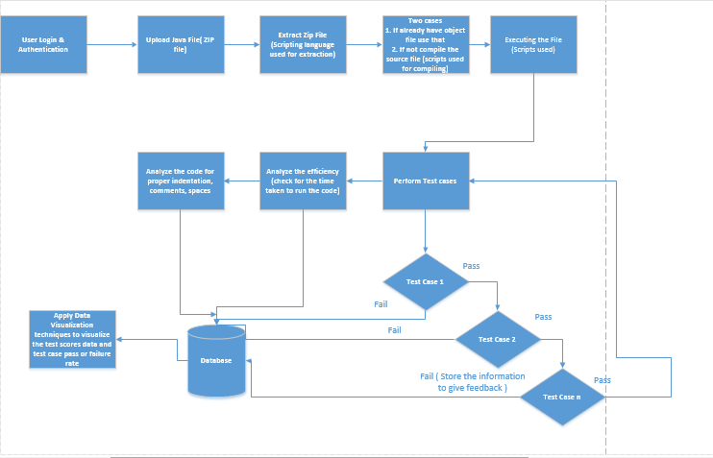

Github Link : <https://github.com/harishbabuachanta/Graduate-Directed-Project.git>